Algebra 2 Name __________________
Chapter 11 Assignment Sheet Hour _________

Chapter 11 Sequences and Series

Pass Objectives: 2.1d, 3.3
Standard 2.1d: Use algebraic, interval, and set notations to specify the domain and range of functions of various types.
Section 3.3: Identify and use arithmetic and geometric sequences and series to solve problems.

Apr. 3 Guided Inquiry: Open/Immerse
HW: Homework WKS Day 1 Sequence and Series Intro

Apr. 4 Guided Inquiry: Immerse Section 11.1 Sequences as Functions
HW: Homework WKS Day 2 Sequence and Series Intro
Apr. 5 Guided Inquiry: Immerse
Arithmetic Sequences and Series Activity

Apr. 6 Guided Inquiry: Immerse Section 11.2 Arithmetic Sequences
KA Resources
HW: Homework WKS Day 3: Arithmetic Sequences

Apr. 7 Guided Inquiry: Immerse Section 11.2 Arithmetic Series
HW: Homework WKS Day 4: Arithmetic Series

Apr. 10 Guided Inquiry: Immerse Section 11.3 Geometric Sequences
HW: Homework WKS Day 5: Geometric Sequences

Apr. 11 Guided Inquiry: Immerse Section 11.3 Geometric Sequences and Series
HW: Homework WKS Day 6: Geometric Series

Apr. 12 Guided Inquiry: Explore
Where are Sequences/Series used in Real Life, Reseach Day, Question Seeking

Apr. 13 Guided Inquiry: Identify and Gather
Group by Topic, Gather more info, Create Rubric for presentation

Apr. 14 Guided Inquiry: Gather and Create
Finish Research, Create Presentations

Apr. 17 Guided Inquiry: Share and Evaluate
Present your Findings by Group, Teacher Evaluation, Student Evaluation
Begin Chapter 11 Review

Apr. 18 HW: Chapter 11 Review
Apr. 19 Chapter 11 Test
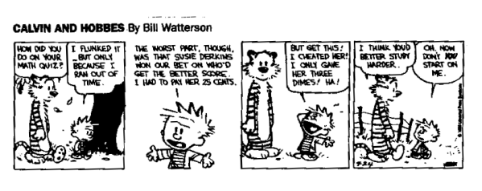
Calvin And Hobbes by Bill Watterson 9/24 Copyright 1990 by Universal Press Syndicate

Chapter 11 Goal: Students will be able to recognize an arithmetic and geometric sequence/series. Students will also be able to write the n^{th} term, find the n^{th} term, and find the sum.

0 – I can find the terms of a sequence.

1 – I can differentiate between arithmetic and geometric and identify the common ratio, the common difference, and the first term.

2 – I can write the rule for an arithmetic or geometric sequence and find any term of the sequence.

3 – I can find the sum of an arithmetic or geometric sequence.

4 – I can write apply geometric and arithmetic rules to real life situations.

Chapter 11 Reflection: Overall, how did this chapter go? What concept(s) do you feel the most confident with? Least confident? How do you feel about the Guided Inquiry process? Did you feel more interested in sequences and series because of it? Why or why not?
___________________________________________________________________________
___________________________________________________________________________
___________________________________________________________________________
___________________________________________________________________________
___________________________________________________________________________
___________________________________________________________________________
___________________________________________________________________________

